An important message from your Food Bank
Neighborhood Backyard Gardeners Can Help Your Food Pantry
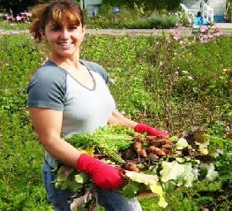
No one needs to tell you how difficult it is to meet the increasing food needs of your community today. We all do our best, but more is needed.
Backyard gardeners in your community can help. They often grow more fruit, vegetables, herbs and nuts during the growing season than they can use and would be happy to share some with your food pantry if only they knew about it.
AmpleHarvest.org⁽℠⁾ was established in 2009 with the goal of enabling millions of America’s gardeners to quickly find a local food pantry in need of fresh produce. It has received support from Google, the White House, your food bank, faith organizations as well as writers/bloggers across the country (see www.AmpleHarvest.org/comments) and was featured on CNN Heroes program (see www.AmpleHarvest.org/cnn).

More than 7,500 food pantries across all 50 states have already registered and more are signing up every day. You are urged to visit www.AmpleHarvest.org/faq to learn more about the AmpleHarvest.org Campaign and to register your pantry.
Adding your pantry is EASY, QUICK and FREE. In addition to entering the name, address, phone and other information about your pantry, you may also upload a digital photograph of the building if you have one, to make it easier to find. You can even list store bought items your pantry most urgently needs for donors who want to help when the gardening season is over.

Refrigerated produce storage is not needed. You can arrange for produce donation and client pickup on a same or next day basis. The AmpleHarvest.org iPhone and Android apps (free) can even help enable the donation of store bought items.

Many home and community gardeners are eager to reach into their backyards to help their neighbors in need. AmpleHarvest.org helps them find you.
We strongly urge you to visit www.AmpleHarvest.org and register your agency today!

Note: Although you register on AmpleHarvest.org via the Internet (you can use a home or public library computer if you like), your pantry does not need to be connected to the Internet to be found on AmpleHarvest.org.

